

**IT4020**

[**Modern Topics in IT**](https://courseweb.sliit.lk/course/view.php?id=3238)

**4rd Year, 1st Semester**

**Augmented Reality Assignment**

**Assignment 03**

Submitted to

Sri Lanka Institute of Information Technology

In partial fulfillment of the requirements for the

Bachelor of Science Special Honors Degree in Information Technology

04-APR-2020

**Declaration**

I certify that this report does not incorporate without acknowledgement, any material previously submitted for a degree or diploma in any university, and to the best of my knowledge and belief it does not contain any material previously published or written by another person, except where due reference is made in text.

Group member details:

|  |  |  |
| --- | --- | --- |
| **Student Name** | **Student ID** | **Email** |
| Hariharan Vasudevan | IT17044400 | hariharansliit@gmail.com |
| Ruchirawya T. H | IT17027984 | harinditharuchirawya@yahoo.com |
| Pabasara M.G.P | IT17077620 | it17077620@my.sliit.lk |
| B K S Geethmi | IT16171398 | It16171398@my.sliit.lk |

1. **Description of each member’s contribution to the application**

* Hariharan Vasudevan

IT17044400

* Making the individual project of AR.
* And merging all the individual projects together.
* Geethmi B K S

IT16171398

* Making the individual project of AR.
* Creating the report
* Ruchirawya T H

IT17027984

* Making the individual project of AR.
* Pabasara M.G.P

IT17077620

* Making the individual project of AR.

**2.0 Screen shots of individual and Group application**

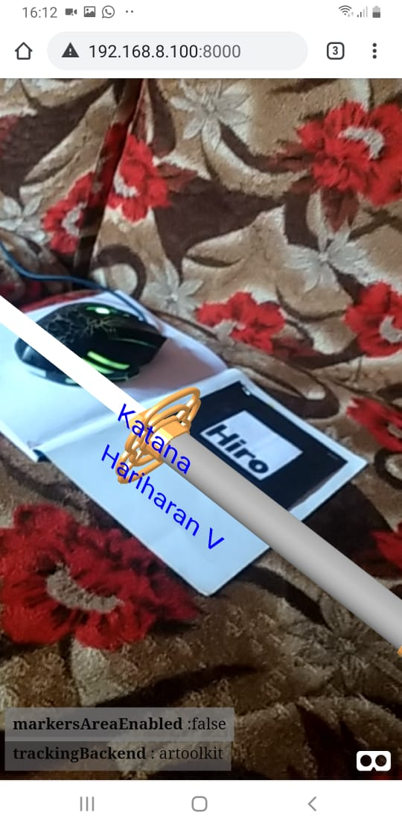

***Figure 2.1 output of Individual application Hariharan***

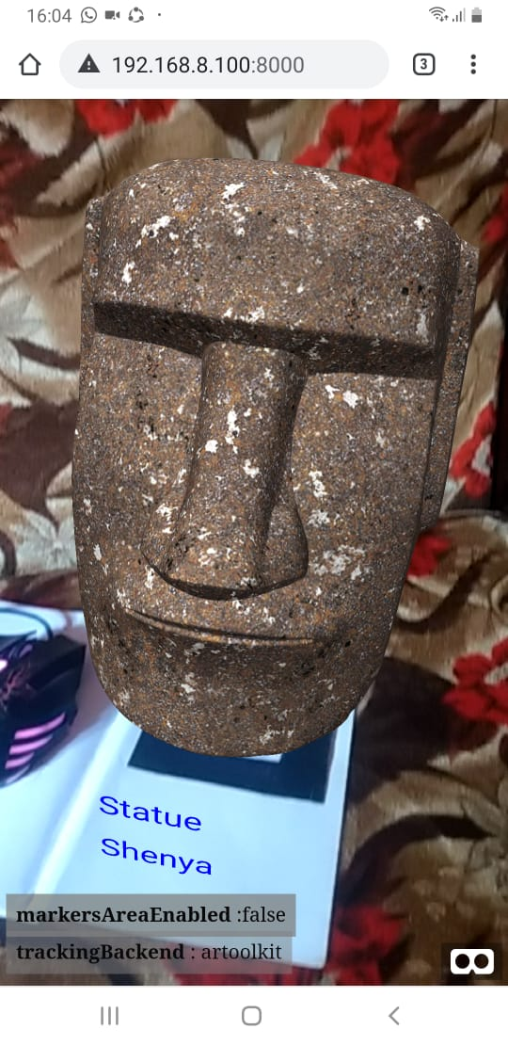

***Figure 2.2 output of Individual application Shenya***

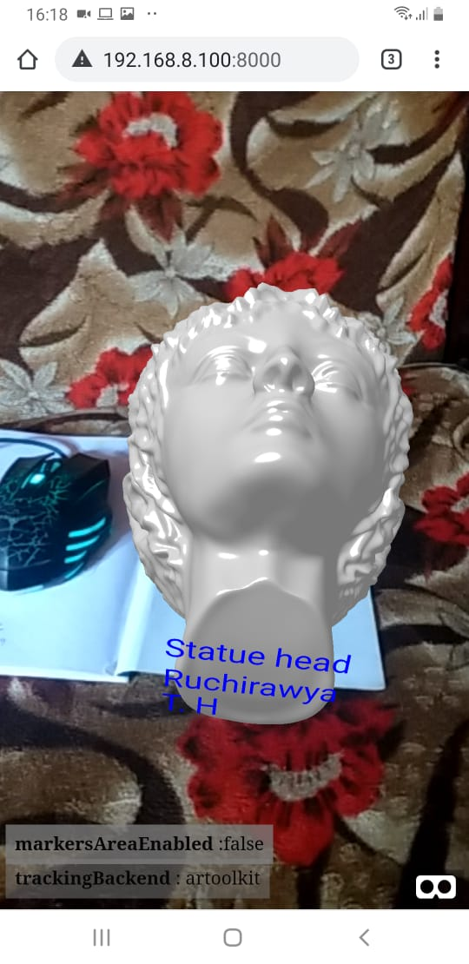

***Figure 2.3 output of Individual application of Ruchirawya***

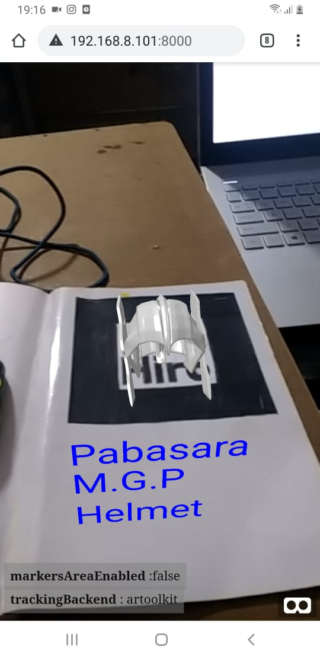

***Figure 2.4 output of Individual application of Pabasara M.G.P***

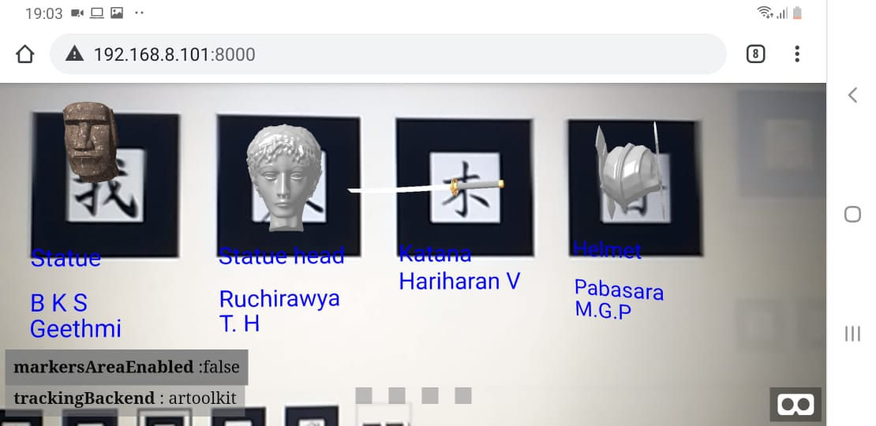

***Figure 2.5 output of Group application***

**4.0 A small write-up about a real-life problem where you can apply AR technology to solve**

AR can be applied in several places, it is really applied in places where we do not have the real artifact or where we want to position some artefact to view its position.

Applied in:

* Wedding hall arrangement
* Architecting
* Interacting game
* And several other places where we want to interact with virtual object in our mind.